**Multicopter Smartphone App installation manual**

**ATTENTION:**

**Always pull the throttle up VERY GENTLY and make sure all Motors spin in the right direction before you pull the throttle up higher.**

1. copy APP (app-debug.apk) to Android Smartphone

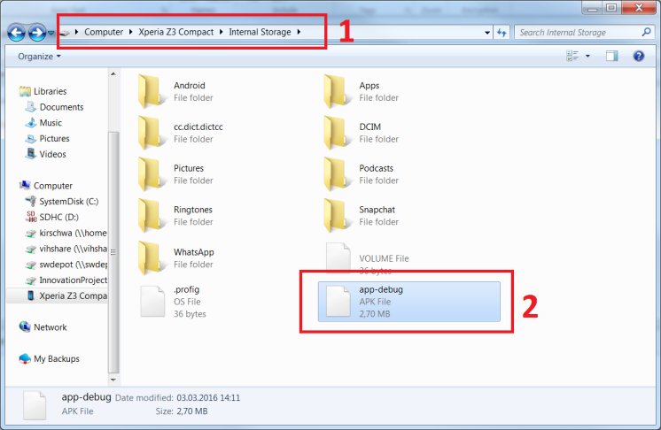

1. Open a File-Explorer on your Android Smartphone and tap on the “app-debug.apk” to install the App on your phone.

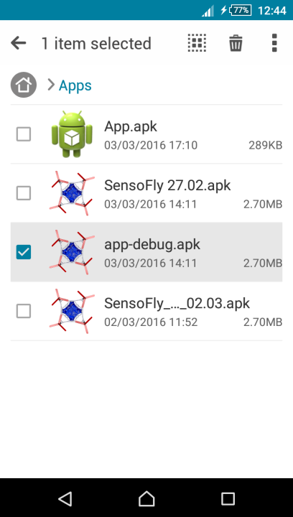

1. Switch on the Multicopter and Radiocontroller (make sure the Bluetooth Switch is ON)
2. Go to the Bluetooth Settings in your Phone 🡪 Pair with “XMC-Bluetooth” 🡪 click on “Pair” when asked.
3. Start the App on your smartphone by tapping the App on the Homescreen
4. App will try to activate Bluetooth once again, select “allow”
5. App will display a notification “Connected” when the connection with the Multicopter is established. Also the LED beneath the Bluetooth Module will turn on, indicating a good connection.
6. Control the Multicopter by tilting the smartphone.